Checkpoints, Lanes, and Vehicle Types Module
Border Entry Payment and Personnel Tracking System
Name | Kyfer Cainoy
Group | Group 3
Module | Checkpoints, Lanes, and Vehicle Types
Database | border_entry_system (MySQL, phpMyAdmin, XAMPP)
Date | November 2026

1. Module Introduction and Purpose
This document explains the module assigned to me in the Border Entry Payment and Personnel Tracking System: Checkpoints, Lanes, and Vehicle Types. It also covers the Lane Report, a JOIN report that connects lanes to their checkpoints.
These three modules hold the basic setup data of the system:
- Checkpoints are the border locations where entries are processed.
- Lanes are the lanes available at each checkpoint. Every lane belongs to one checkpoint.
- Vehicle Types are the categories of vehicles that enter the border, such as Motorcycle, Car, Van, Bus, and Truck. Each type has a base fee that the payment side of the system can use.
The modules are written in PHP and connect to the MySQL database border_entry_system through the group's shared db.php file. The files I created are:
File | Description
database/kyf_tables.sql | CREATE TABLE statements for checkpoints, lanes and vehicle_types
php/kyfer/helpers.php | Shared page layout, navigation bar, styling, and the h() output-escaping function
php/kyfer/checkpoints.php | Checkpoint management page
php/kyfer/lanes.php | Lane management page
php/kyfer/vehicle_types.php | Vehicle type management page
php/kyfer/lane_report.php | Lane Report page (JOIN of lanes and checkpoints)
reports/kyfer_join.sql | The JOIN query saved as an SQL file

2. Tables Used and Their Descriptions
My module uses three tables. Their structures in phpMyAdmin are shown in Figures 14 to 16, and the foreign key in Figure 17.

2.1 checkpoints
Stores one row for each border checkpoint.
Column | Type | Description
id | INT, AUTO_INCREMENT, PRIMARY KEY | Unique ID of the checkpoint
checkpoint_name | VARCHAR(100), NOT NULL | Name of the checkpoint
location | VARCHAR(100), NULL allowed | Where the checkpoint is located

2.2 lanes
Stores the lanes of each checkpoint.
Column | Type | Description
id | INT, AUTO_INCREMENT, PRIMARY KEY | Unique ID of the lane
checkpoint_id | INT, NOT NULL, FOREIGN KEY | The checkpoint this lane belongs to. References checkpoints.id (constraint lanes_ibfk_1, ON DELETE RESTRICT, ON UPDATE RESTRICT)
lane_number | INT, NOT NULL | The lane number at that checkpoint

2.3 vehicle_types
Stores the vehicle categories and their base fee.
Column | Type | Description
id | INT, AUTO_INCREMENT, PRIMARY KEY | Unique ID of the vehicle type
type_name | VARCHAR(50), NOT NULL | Name of the vehicle type
base_fee | DECIMAL(10,2), NOT NULL | Base fee for that vehicle type

2.4 Relationships
- checkpoints to lanes: one-to-many. One checkpoint can have many lanes, and every lane must belong to exactly one existing checkpoint.
- vehicle_types: a standalone table. No other table references it yet.
- Naming rules followed: the primary key is id and a foreign key is named tablename_id.
Data in the tables during testing: checkpoints has 1 row (Main Entry Checkpoint, Border Entry Point), lanes has 4 rows (lanes 1 to 4 of Main Entry Checkpoint), and vehicle_types has 5 rows: Motorcycle (20.00), Car (50.00), Van (80.00), Bus (100.00), and Truck (150.00).

3. Main Functions and Features

3.1 Checkpoint management (checkpoints.php)
- View all checkpoints in a table with ID, name, and location.
- Add a checkpoint. The name is required and the location is optional.
- Edit a checkpoint. The Edit button fills the form with the current values, and Save Changes updates the row.
- Delete a checkpoint after confirming in a popup.
- A checkpoint that still has lanes cannot be deleted. The page shows a clear error message instead.

3.2 Lane management (lanes.php)
- View all lanes with the checkpoint name shown, not only its ID number.
- Add a lane by choosing an existing checkpoint from a dropdown and entering a lane number.
- Edit a lane. The dropdown keeps the correct checkpoint selected.
- Delete a lane after confirming in a popup.
- Validation: a checkpoint must be chosen, and the lane number must be a whole number of 1 or higher.

3.3 Vehicle type management (vehicle_types.php)
- View all vehicle types with the base fee shown to 2 decimal places.
- Add, edit, and delete vehicle types.
- Validation: the name is required (maximum 50 characters). The fee is required and must be a non-negative number with up to 2 decimal places.

3.4 Lane Report (lane_report.php)
- A read-only report that lists every lane together with its checkpoint (Lane ID, Lane Number, Checkpoint ID, Checkpoint Name, Location) and a "Total lanes" count.

3.5 Features shared by all pages
- The same layout, navigation bar, and colors on every page (from helpers.php).
- Green success messages and red error messages.
- Prepared statements for all database queries, and escaping of all output.

4. CRUD Operations
All three management pages implement the full set of CRUD operations. The Lane Report is read-only.
Operation | Checkpoints | Lanes | Vehicle Types
Create | INSERT INTO checkpoints (checkpoint_name, location) VALUES (?, ?) | INSERT INTO lanes (checkpoint_id, lane_number) VALUES (?, ?) | INSERT INTO vehicle_types (type_name, base_fee) VALUES (?, ?)
Read | SELECT id, checkpoint_name, location FROM checkpoints ORDER BY id | SELECT l.id, l.lane_number, c.checkpoint_name FROM lanes l INNER JOIN checkpoints c ON l.checkpoint_id = c.id | SELECT id, type_name, base_fee FROM vehicle_types ORDER BY id
Update | UPDATE checkpoints SET checkpoint_name = ?, location = ? WHERE id = ? | UPDATE lanes SET checkpoint_id = ?, lane_number = ? WHERE id = ? | UPDATE vehicle_types SET type_name = ?, base_fee = ? WHERE id = ?
Delete | DELETE FROM checkpoints WHERE id = ? (blocked if lanes exist) | DELETE FROM lanes WHERE id = ? | DELETE FROM vehicle_types WHERE id = ?

The ? marks are prepared-statement placeholders. The values are sent to MySQL separately from the SQL text, which prevents SQL injection.

5. Screenshots of the Implementation

5.1 Checkpoints page
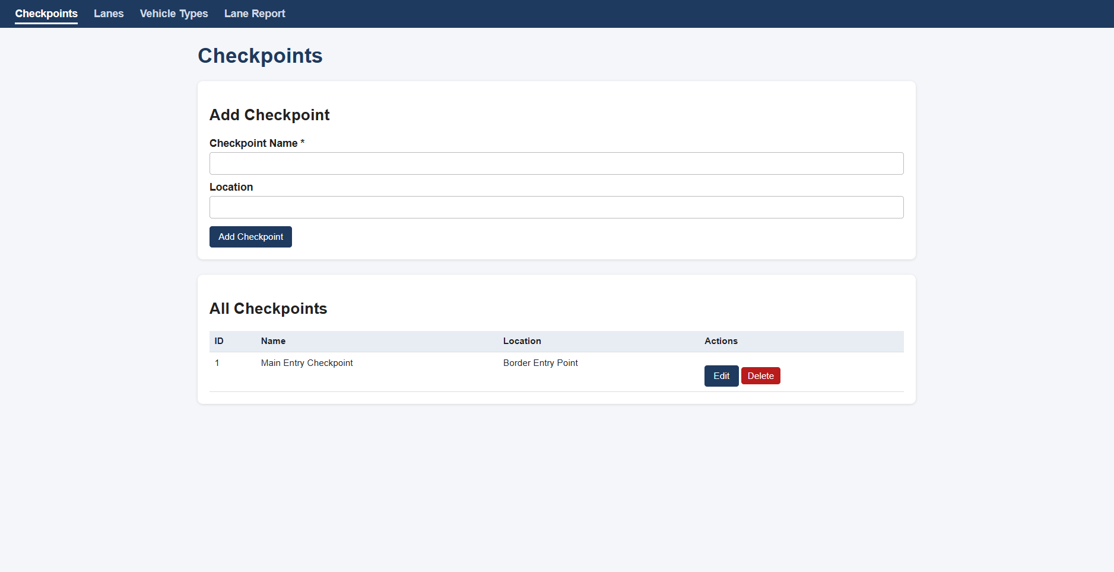
Figure 1. Checkpoints page: the Add Checkpoint form and the table of all checkpoints.
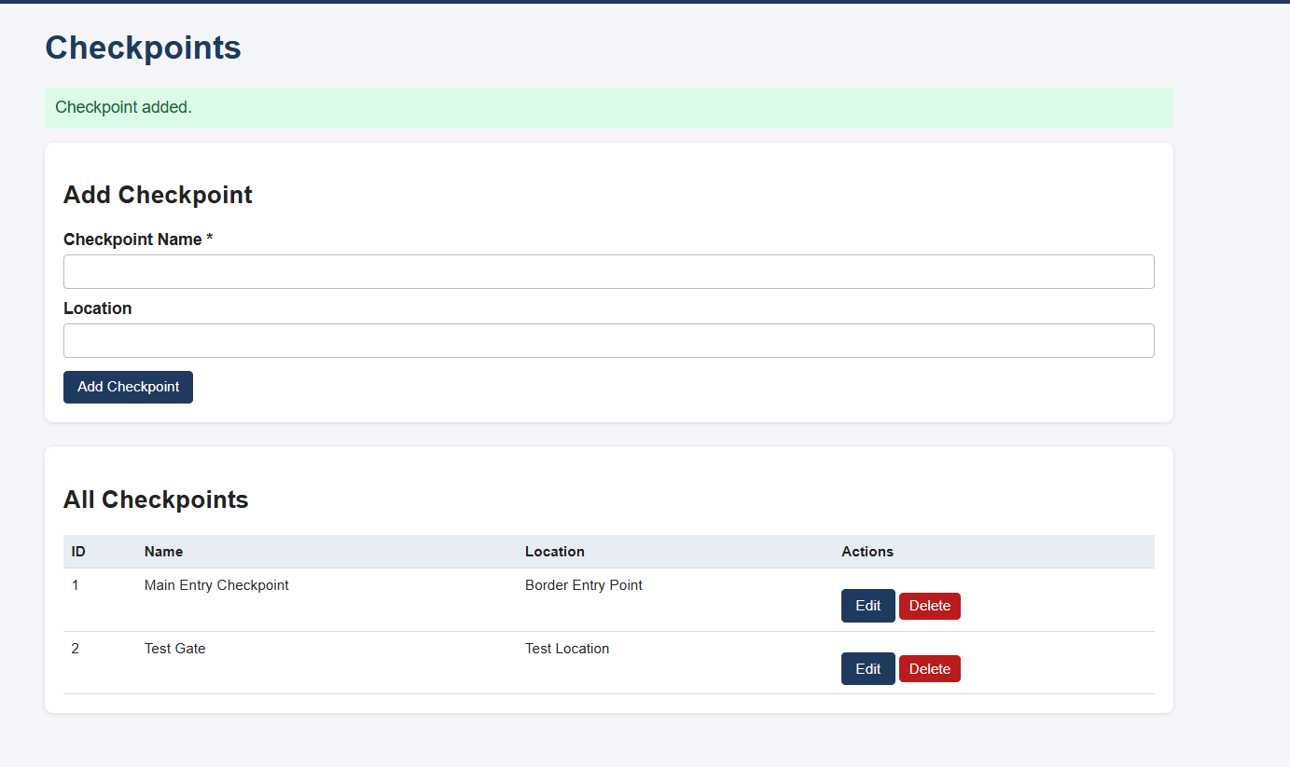
Figure 2. Adding a checkpoint ("Test Gate") shows a green success message and the new row.
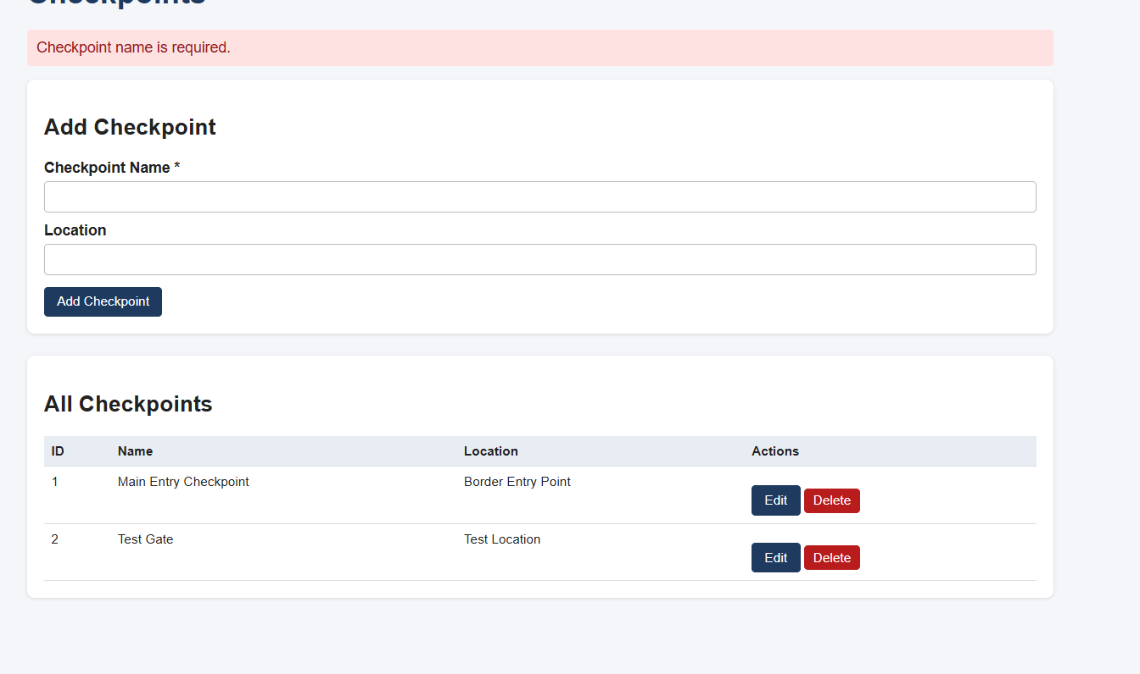
Figure 3. Validation: adding with a blank name shows the red error "Checkpoint name is required."
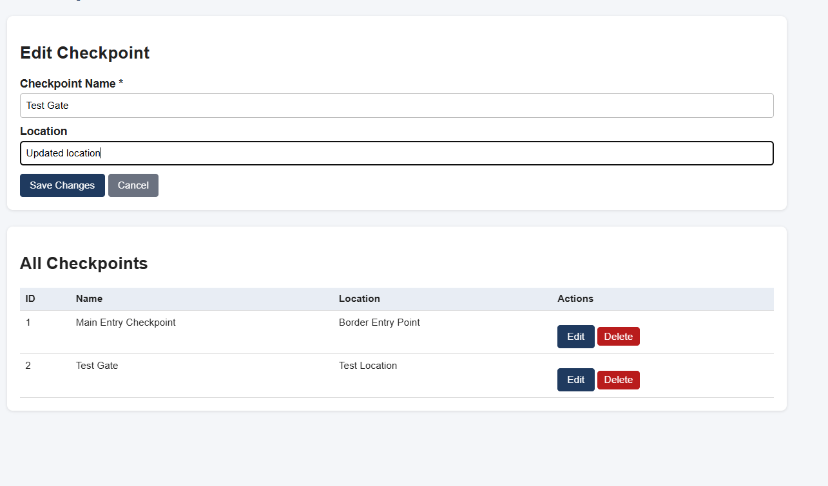
Figure 4. Editing a checkpoint: the form is filled with the existing values and the heading changes to Edit Checkpoint.
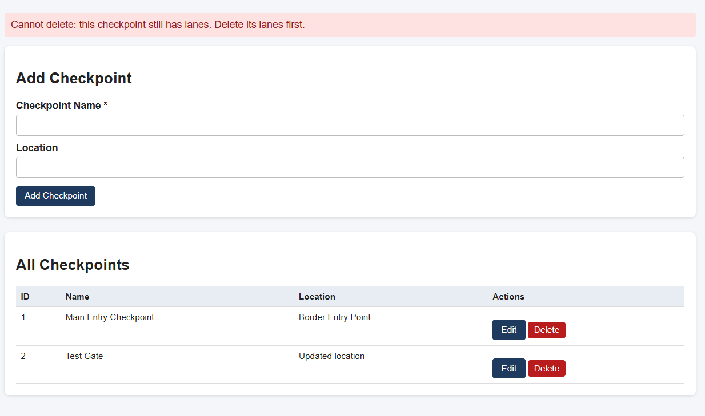
Figure 5. Deleting Main Entry Checkpoint is blocked because it still has lanes.

5.2 Lanes page
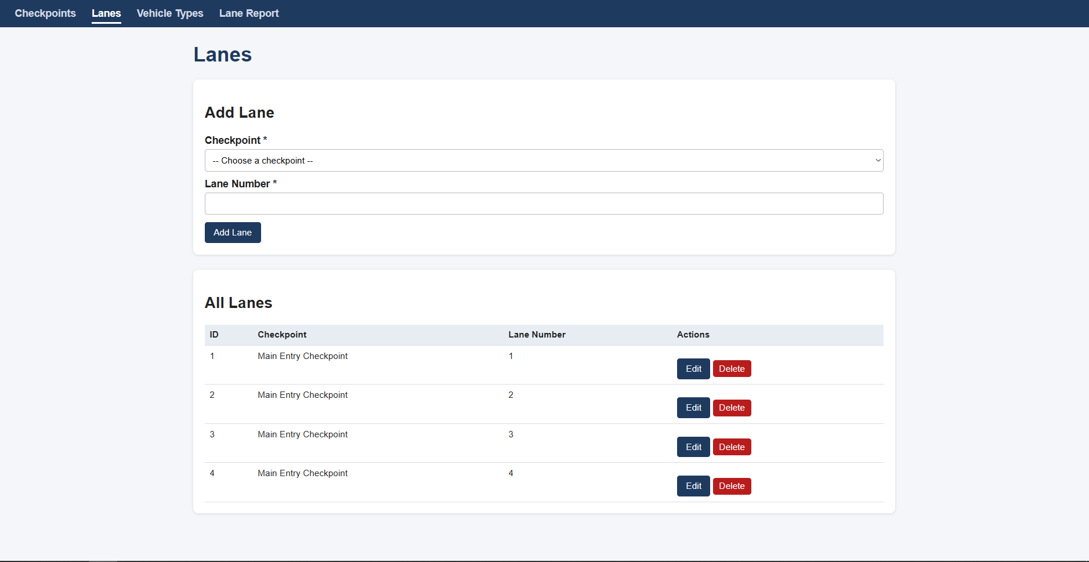
Figure 6. Lanes page: the checkpoint dropdown, the lane number field, and the table showing the checkpoint name of each lane.
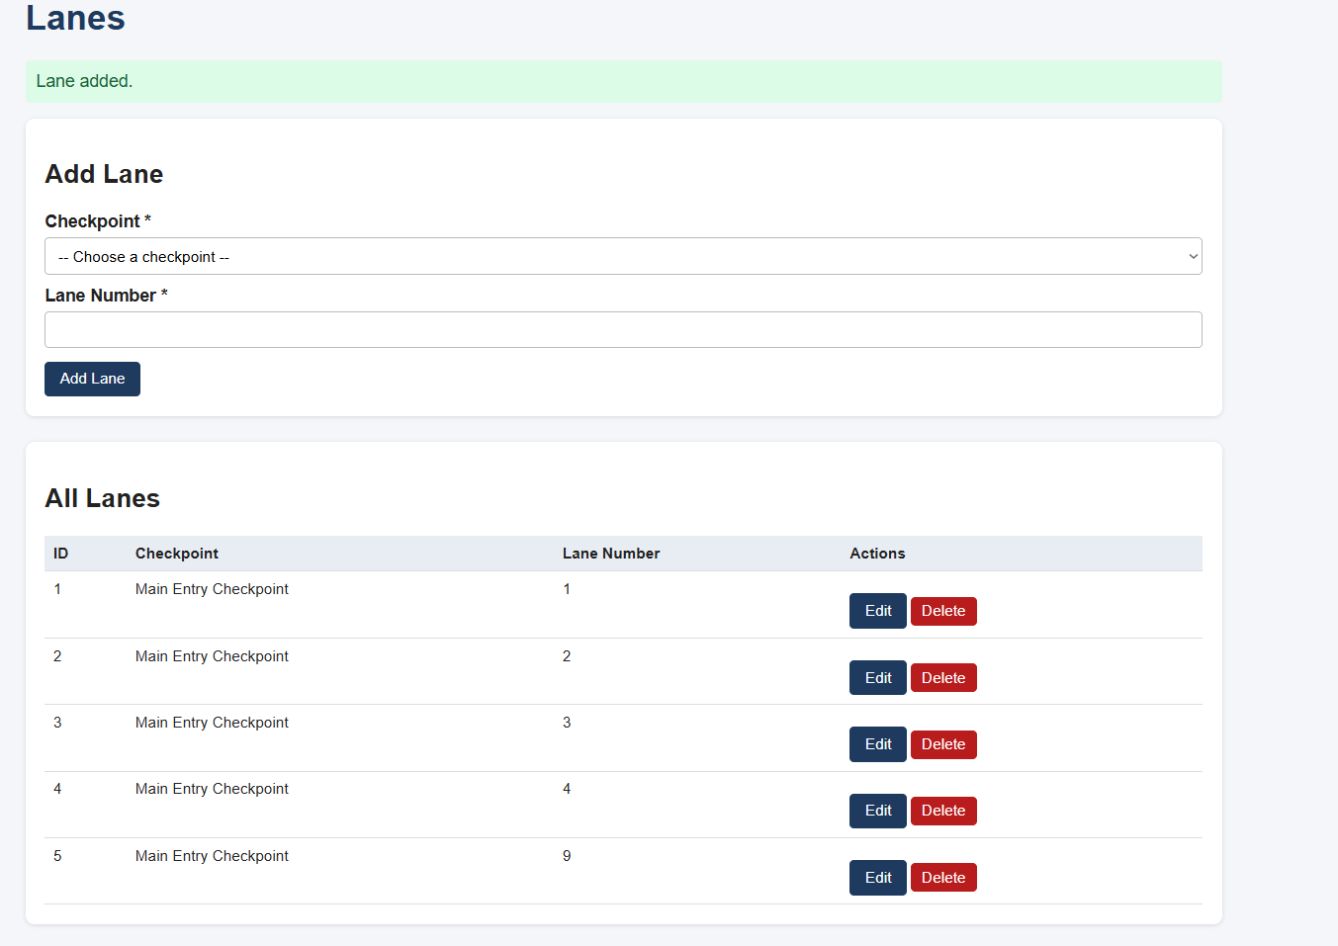
Figure 7. Adding lane 9 shows "Lane added." and the new lane (ID 5) with the correct checkpoint name.
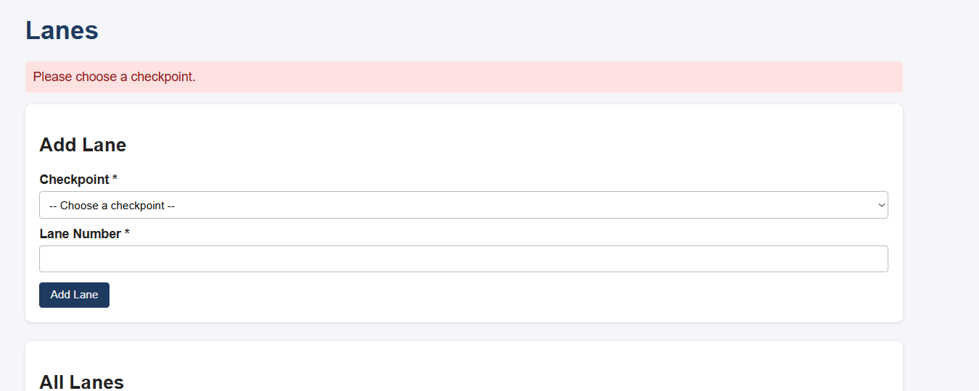
Figure 8. Validation: adding without choosing a checkpoint shows "Please choose a checkpoint."
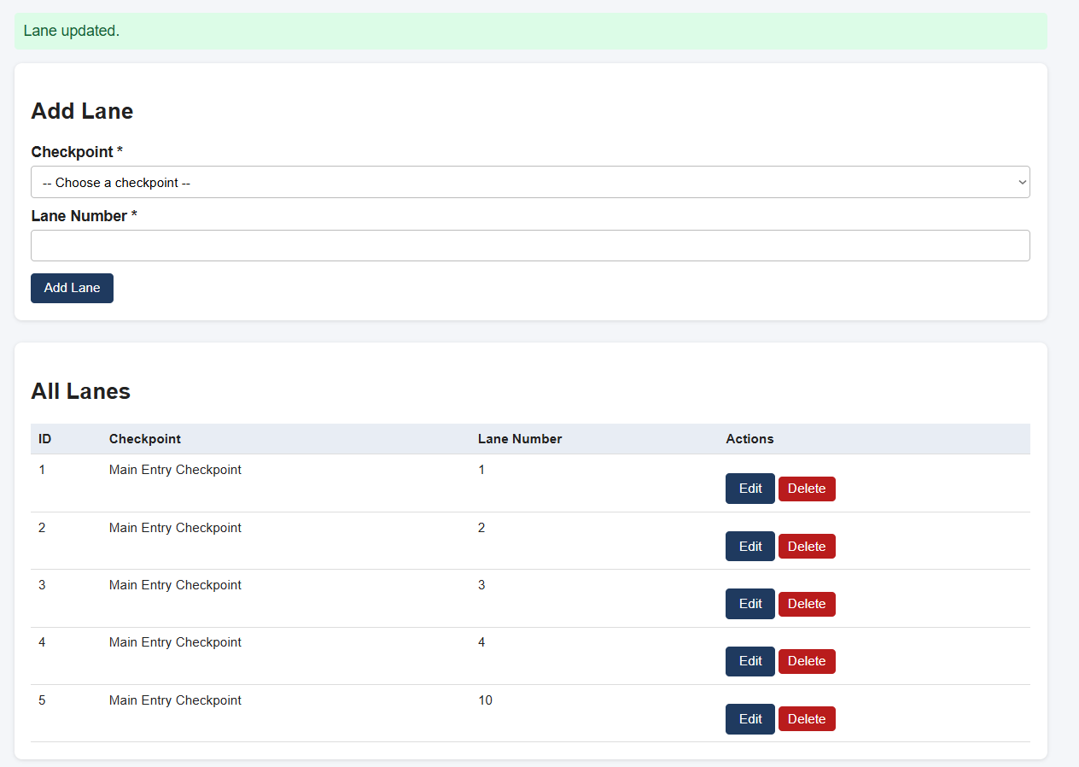
Figure 9. Editing the test lane from 9 to 10 shows "Lane updated."

5.3 Vehicle Types page
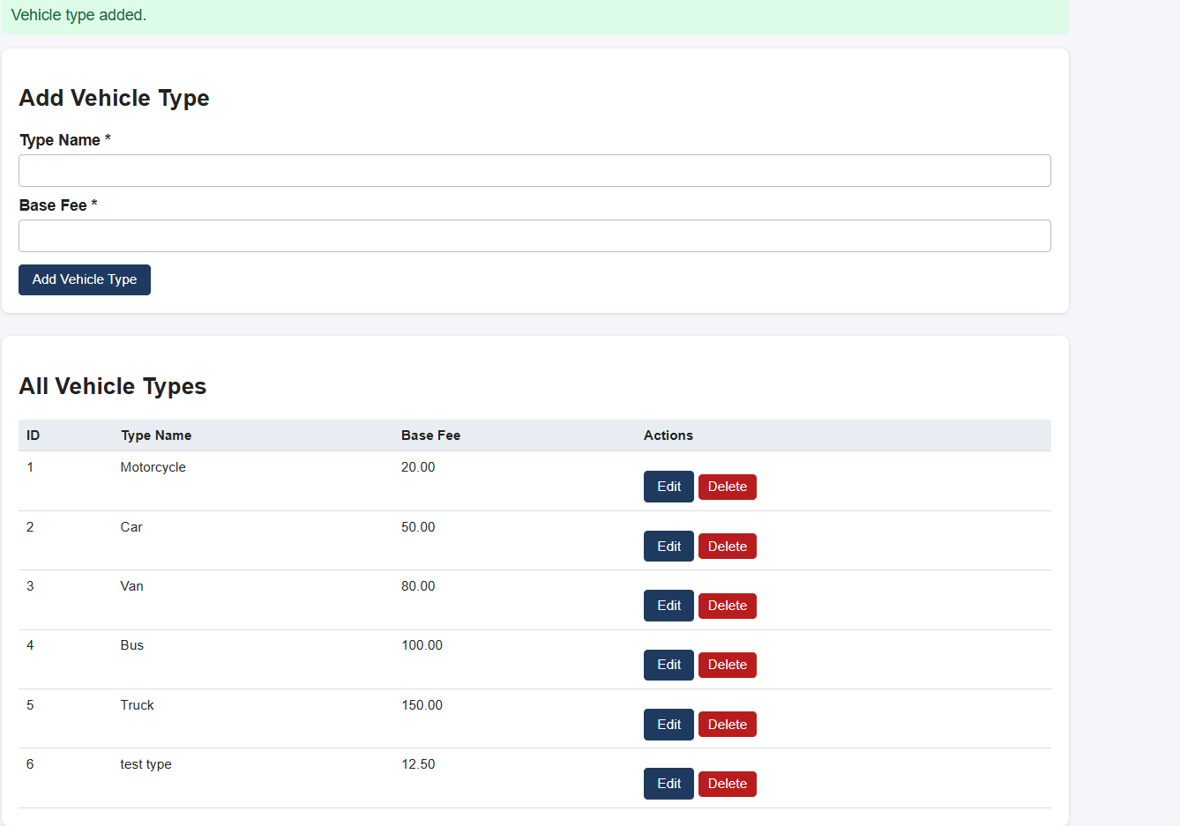
Figure 10. Vehicle Types page: the 5 existing types with their fees, and a newly added test type with fee 12.50.
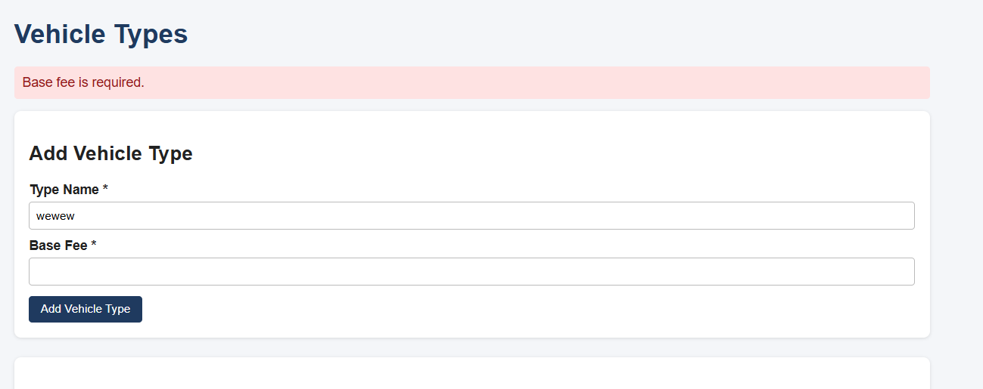
Figure 11. Validation: a name with a blank fee shows "Base fee is required."
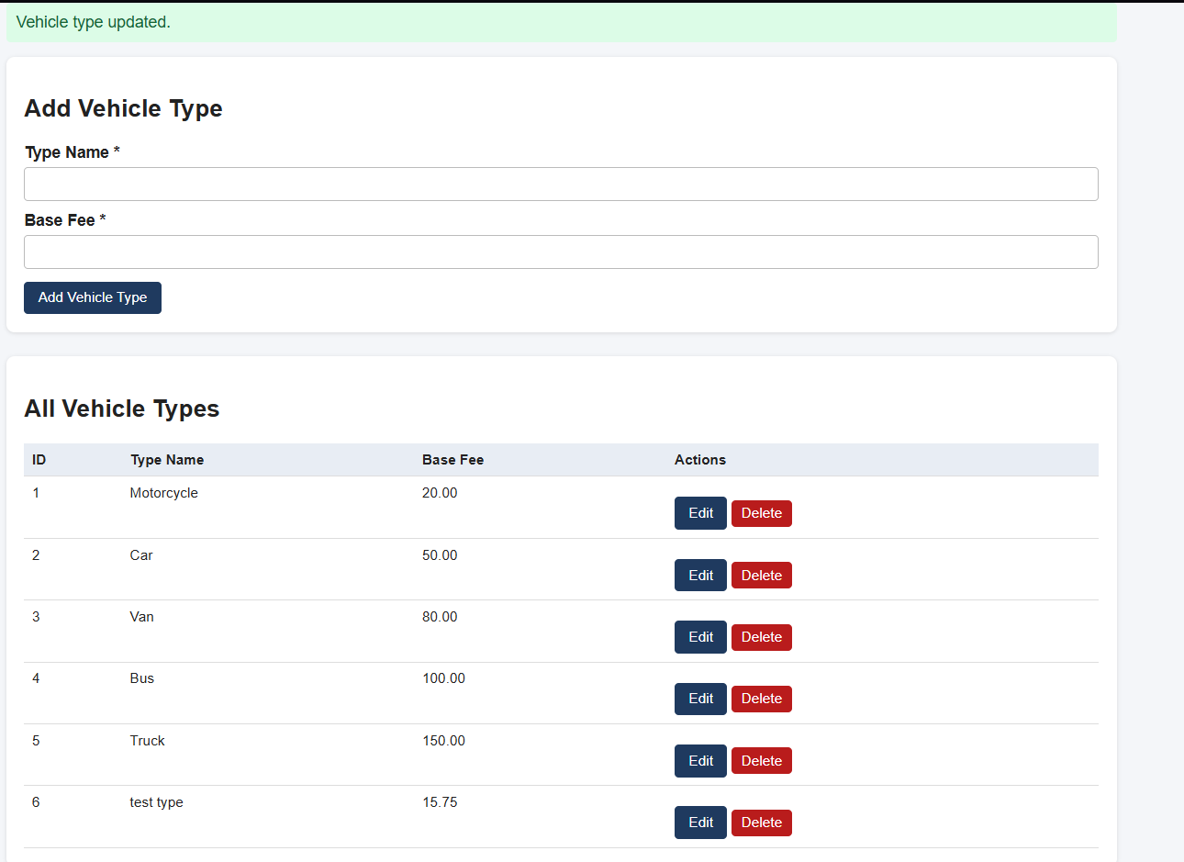
Figure 12. Editing the test type's fee to 15.75 shows "Vehicle type updated."

5.4 Lane Report
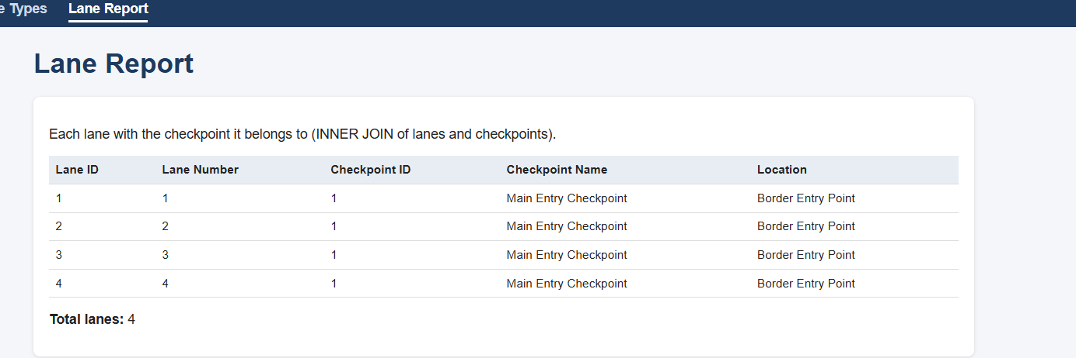
Figure 13. Lane Report page: each lane with its checkpoint, and the total number of lanes.

5.5 Database (phpMyAdmin)
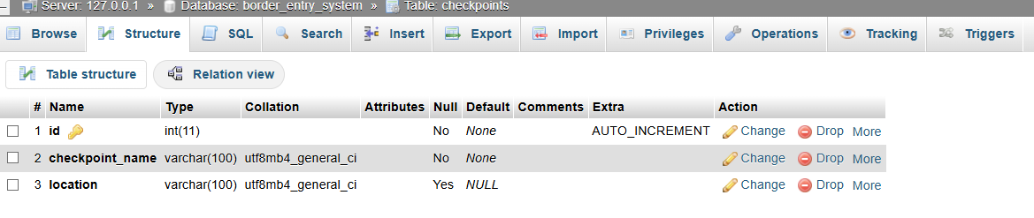
Figure 14. Structure of the checkpoints table.
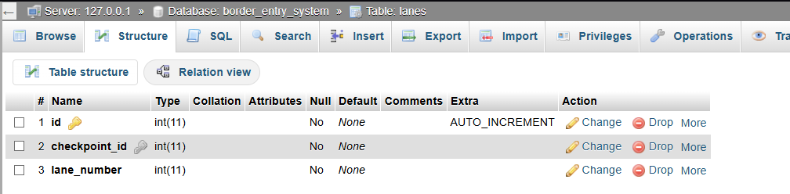
Figure 15. Structure of the lanes table.
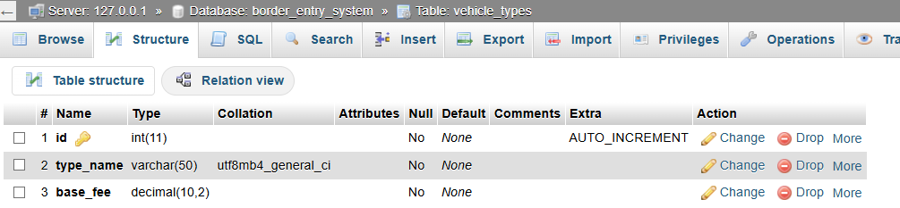
Figure 16. Structure of the vehicle_types table.
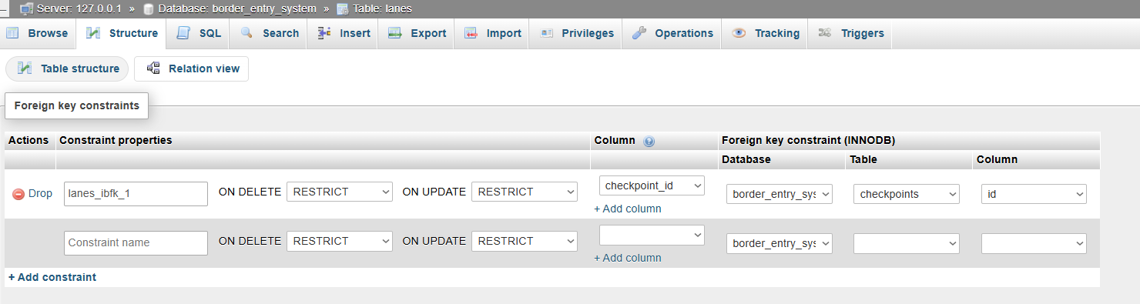
Figure 17. Relation view of the lanes table: the foreign key lanes_ibfk_1 from checkpoint_id to checkpoints.id (RESTRICT).
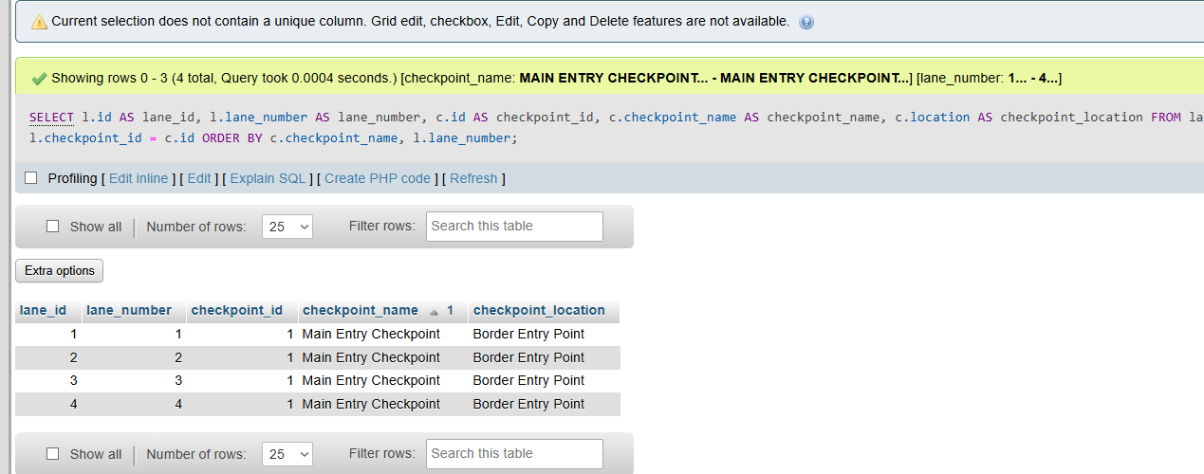
Figure 18. The JOIN query run in phpMyAdmin, with its 4 result rows.
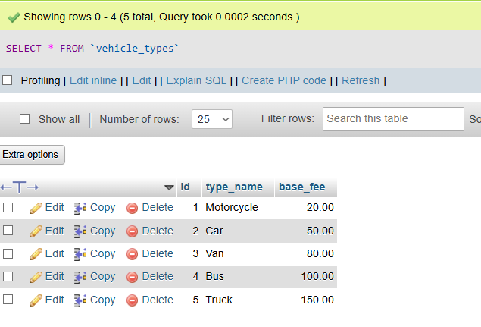
Figure 19. The vehicle_types table in phpMyAdmin after the test row was deleted: the original 5 rows.

6. How the Module Works

6.1 Overall flow
The user opens a page in a web browser. The PHP page runs on the Apache web server (XAMPP), connects to MySQL through the shared db.php file, runs the needed queries, and sends the result back to the browser as an HTML page.
Browser -> PHP page (checkpoints.php / lanes.php / vehicle_types.php)
-> db.php (shared connection) -> MySQL border_entry_system

6.2 Steps inside every management page
- The page loads db.php (the connection) and helpers.php (layout and the h() function).
- If a form was submitted (POST), the page reads which action was sent (add, edit, or delete), validates the input, and runs the matching prepared statement.
- If the Edit button was clicked (?edit=ID in the address), the chosen row is loaded into the form.
- The page reads the table from the database and prints it as an HTML table, with a green or red message at the top.

6.3 Checkpoint management
The form uses a hidden action field that is set to add or edit. The name is trimmed and checked, and an empty name stops the save. When a delete is requested, MySQL refuses it with error 1451 if a lane still points to the checkpoint. The page catches that error and shows "Cannot delete: this checkpoint still has lanes. Delete its lanes first." This is referential integrity protecting the data.

6.4 Lane management
The checkpoint dropdown is filled by reading the checkpoints table, so a lane can only be linked to an existing checkpoint. The option value is the checkpoint id, which is what the database stores, and the label is the checkpoint name, which is what people read. The lane list uses an INNER JOIN so the table can show the checkpoint name instead of only a number:
SELECT l.id, l.lane_number, c.checkpoint_name
FROM lanes l
INNER JOIN checkpoints c ON l.checkpoint_id = c.id
ORDER BY c.checkpoint_name, l.lane_number;

INNER JOIN is correct because every lane must belong to a checkpoint, so no lane is lost. If MySQL reports error 1452 (the checkpoint does not exist), the page shows "That checkpoint does not exist."

6.5 Vehicle type management
The base fee is checked in PHP with the pattern ^\d{1,8}(\.\d{1,2})?$, which allows only a non-negative number with up to 2 decimal places. This matches the DECIMAL(10,2) column. The browser form also uses min="0" as a first check. The fee is shown with number_format so it always appears with 2 decimals.

6.6 Lane Report
The report runs the query saved in reports/kyfer_join.sql. It joins lanes and checkpoints on lanes.checkpoint_id = checkpoints.id:
SELECT l.id AS lane_id, l.lane_number AS lane_number,
c.id AS checkpoint_id, c.checkpoint_name AS checkpoint_name,
c.location AS checkpoint_location
FROM lanes l
INNER JOIN checkpoints c ON l.checkpoint_id = c.id
ORDER BY c.checkpoint_name, l.lane_number;

l and c are short names (aliases) for the tables, and the AS names keep the two id columns from clashing. A LEFT JOIN would also list checkpoints that have no lanes.

6.7 Security and safety measures
- Prepared statements with bind_param keep user input separate from the SQL, which prevents SQL injection.
- Output escaping with h() (htmlspecialchars) makes database text safe before it is printed, which prevents cross-site scripting (XSS).
- Server-side validation checks required fields and value formats in PHP, not only in the browser.
- Delete confirmation asks the user to confirm before any record is deleted.

7. Testing and Verification Performed
All pages were tested on 8 November 2026 on a local XAMPP setup. After each test, the result was also checked in phpMyAdmin. Temporary test rows were deleted afterwards, so the tables returned to their original data.

7.1 Checkpoints
Step taken | Actual outcome
Opened the page | The existing "Main Entry Checkpoint" was displayed (Figure 1)
Added "Test Gate" with location "Test Location" | Green "Checkpoint added." and the new row appeared (Figure 2)
Clicked Add with a blank name | Red "Checkpoint name is required." and nothing was saved (Figure 3)
Edited the location of Test Gate | Green "Checkpoint updated." and the new location was shown (Figure 4)
Tried to delete Main Entry Checkpoint (it has lanes) | Blocked with the "still has lanes" message and the row stayed (Figure 5)
Deleted Test Gate | Green "Checkpoint deleted." and the row was removed
Checked checkpoints in phpMyAdmin | Only the original row remained, matching the page

7.2 Lanes
Step taken | Actual outcome
Opened the page | The 4 existing lanes were shown with "Main Entry Checkpoint" (Figure 6)
Opened the checkpoint dropdown | It listed the existing checkpoint
Added lane 9 for Main Entry Checkpoint | Green "Lane added." and the new lane showed the correct checkpoint name (Figure 7)
Clicked Add with no checkpoint chosen | Red "Please choose a checkpoint." (Figure 8)
Chose a checkpoint and left the lane number blank | Red message that the lane number is required, and the dropdown kept its selection
Edited lane 9 to 10 | Green "Lane updated." and 10 was shown (Figure 9)
Deleted the test lane | Green "Lane deleted."
Checked lanes in phpMyAdmin | The original 4 rows (IDs 1 to 4) remained

7.3 Vehicle Types
Step taken | Actual outcome
Opened the page | 5 vehicle types were shown with fees to 2 decimals (Figure 10)
Added a test type with fee 12.50 | Green "Vehicle type added." and the row showed 12.50
Entered a name and left the fee blank | Red "Base fee is required." (Figure 11)
Entered a fee and left the name blank | Red "Vehicle type name is required."
Left both fields blank | Red "Vehicle type name is required."
Entered a fee of -5 | The browser blocked it with "Value must be greater than or equal to 0."
Edited the fee to 15.75 | Green "Vehicle type updated." and 15.75 was shown (Figure 12)
Deleted the test row | Green "Vehicle type deleted."
Checked vehicle_types in phpMyAdmin | The original 5 rows remained (Figure 19)

7.4 Lane Report and JOIN query
Step taken | Actual outcome
Ran the JOIN query in phpMyAdmin | 4 rows: lanes 1 to 4, all Main Entry Checkpoint at Border Entry Point (Figure 18)
Opened lane_report.php in the browser | The same 4 rows and "Total lanes: 4" (Figure 13)

7.5 Limitations
These are the known limitations of my module, based on the actual implementation:
- The tables have only basic columns. There are no description, status, or lane type fields.
- entry_records and vehicles are not linked to checkpoints, lanes, or vehicle types yet.
- A checkpoint cannot be deleted until its lanes are deleted, and deletions are permanent.
- The same lane number can be added twice for one checkpoint, because there is no unique constraint on checkpoint_id and lane_number.
- There is no search or pagination, and the pages have no login or role checks of their own.
- Refreshing the page right after a successful action can resubmit the form.

